European deaf sport organization  www.deafsports-edso.eu | 

Edward G. Webb,  9 Windsor Grove,  Ashton-Under-Lyne,  Tameside, Great Manchester,  OL6 8UU, GREAT BRITAIN,  E-Mail : teddywebb@aol.com (Home)  Fax : +44 161 344 2115 (Home)  EDSO Office ;  E-Mail : secretary@deafsports-edso.eu  Fax : +44 161 273 8435 | Closing Date  Preliminary Entry :- 30.11.2006  Final Date :- 1.03.2007  Registration :- 8.08.2007

11th European Deaf Shooting Championships  from 8th until 15th September 2007  in Geneve / Switzerland | 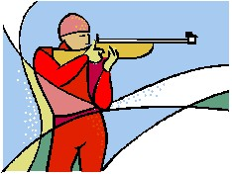

We will participate in the European Deaf Championships of Shooting :

Women : Yes No

Men : Yes No

___________________________________________________________________

Name of the Organistation : __________________________________________

Address ; _________________________________________________________

_________________________________________________________

_________________________________________________________

E – Mail _________________________________________________________

Fax : _________________________________________________________

President ______________________ Secretary ______________________

Date __________________ Place ___________________

