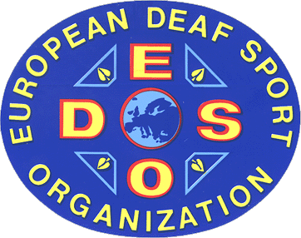

E U R O P E A N D E A F S P O R T O R G A N I Z A T I O N

Founded on 7th July 1983 in Antibes/France

EDSO Official Bjørn Røine, Sømveien 6A, 0493 Oslo, Norway Mail: broine@online.no Fax: + 47 22 22 57 19

2nd European Championships of FUTSAL
from 10th until 18th November 2006 in Moscow/RUS

Registration before 10th October 2006

COUNTRY: WOMEN

PLAYERS:
 | Family Name | First Name | Date of Birth | ICSD Audiogram  Yes No
1.
2.
3.
4.
5.
6.
7.
8.
9.
10.
11.
12.
All Shirt No. MUST allocate to said player throughout the Championship

OFFICIALS:
 | Family Name | First Name | Function
1.
2.
3.
4.
5.
6.
Note:
Any new participant must send their audiogram before they can take part!

_____________________ ____________________ ___________________ Place, date President Secretary

