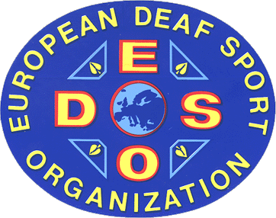

E U R O P E A N D E A F S P O R T O R G A N I Z A T I O N

9th European Deaf Basketball Championships
for women and men
from 20th until 28th June 2008 in Bamberg/GER

Vasyl Sandugei  EC-Member  Str. Esplanadna, 42, apt.912  01001 Kiev  UKRAINE  Fax Privat +380 444280536.  E-Mail sandvasyul@mail.ru | Final entry: 20.08.2007  Registration by name: 20.05.2008  Please!!! We ask you to return this form to the EDSO even if your country is not intending to participate. It ist important for our preparaions! Thank you!
We will participate in the European Basketball Championships:

Women Team: Yes  No 

Men Team: Yes  No 

Country: ______________________________________________

Name of the organistaion: ______________________________________________

Adress: ______________________________________________

______________________________________________

______________________________________________

E-Mail: ______________________________________________

Telefax: ______________________________________________

_____________________ ____________________ ______________

