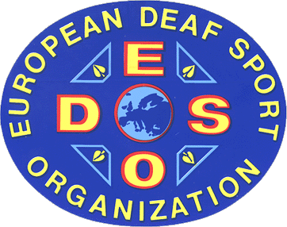

E U R O P E A N D E A F S P O R T O R G A N I Z A T I O N
Founded on 7th July 1983 in Antibes/France

7th European Athletics Championships  from 09 until 14 July 2007 in Sofia/BUL | 

Men | number | Women |  | number
(max. 3 athletes per event) | of | (max. 3 athletes per event) |  | of
 | athletes |  |  | athletes
100 m |  | 100 m
200 m |  | 200 m
400 m |  | 400 m
800 m |  | 800 m
1.500 m |  | 1.500 m
5.000 m |  | 5.000 m
10.000m |  | 10.000m
110 m Hurdles |  | 100 m Hurdles
400 m Hurdles |  | 400 m Hurdles
3.000 m Steeplechase |  | 3.000 m Steeplechase
4 x 100 Relay |  | 4 x 100 Relay
4 x 400 Relay |  | 4 x 400 Relay
Pole vault |  | Pole vault
High jump |  | High jump
Long jump |  | Long jump
Triple jump |  | Triple jump
Shot put |  | Shot put
Discus |  | Discus
Hammer |  | Hammer
Javelin |  | Javelin
Decathlon |  | Heptathlon
21 events |  | 21 events
Name of the organization | ____________________________________________________
 | President | Secretary General

